Bullying, EEO, Discrimination & Harassment Policy

Date | Version | Changes
Jan 2018 | 1.0 | Policy basic draft
Jan 2019 | 2.0 | Changes made in light of complaints
Contents
Bullying, EEO, Discrimination & Harassment Policy 1
Introduction 3
Values 3
Diversity 3
Bullying and Harassment 3
Bullying 3
Harassment can include, but is not exclusive to: 4
Discrimination 4
Purpose 5
Scope 5
Policy 5
Roles and Responsibilities 6
The CEO will 7
Students and staff will: 7
An external or internal mediator will: 7
Any investigator will: 8
Process 8
Process (cont) 9
Process in detail 9
Definitions and acronyms 10
References 12

Introduction
AIHE endeavours to conduct its business in a way which encourages fair, equitable and non-discriminatory operational practices and equal opportunity for all. AIHE’s reputation and success depends on the professionalism displayed by its people.

Values
AIHE values its people and in doing so, it is AIHE’s endeavour to provide an environment that maximises the talent, potential and contribution of all people and which encourages equal opportunity for all.

Diversity
AIHE recognises that diversity in the workplace and learning environment adds value to our business through different perspectives and experiences. The term diversity in the workplace and environment means that people differ from each other and subsequently, they have a wide range of different attributes, needs, skills and experiences.

Bullying and Harassment
It is against the law to bully or harass a staff member or student.
Under discrimination law, it is unlawful to treat a person less favourably on the basis of particular protected attributes. Treating a person less favourably can include harassing or bullying a person. The law also has specific provisions relating to sexual harassment, racial hatred and disability harassment.

Bullying
The Fair Work Amendment Act 2013 defines workplace bullying as repeated unreasonable behaviour by an individual towards a worker which creates a risk to health and safety. Behaviour can range from obvious verbal or physical assault to subtle psychological abuse.
It can include
- physical or verbal abuse via text, email or face to face.
- yelling, screaming or offensive language
- excluding or isolating employees
- psychological harassment
- intimidation
- assigning meaningless tasks unrelated to the job
- giving employees impossible jobs
- deliberately changed work rosters to inconvenience particular employees
- undermining work performance by deliberately withholding information vital for effective work performance.

Harassment can include, but is not exclusive to:
- telling insulting jokes about particular racial groups
- sending explicit or sexually suggestive emails or text messages
- displaying racially offensive or pornographic posters or screen savers
- making derogatory comments or taunts about a person’s disability, or
- asking intrusive questions about someone’s personal life, including his or her sex life
- making comments about an individual in a bullying or harassing way where it the purpose is to offend.
AIHE will not tolerate any form of bullying in the workplace or learning environment.

Discrimination
It is against the law to discriminate for any reason including discrimination on the basis of age, race, colour, sex, religion, political opinion, national extraction, social origin, age, medical record, criminal record, marital or relationship status, impairment, mental, intellectual or psychiatric disability, physical disability, nationality, sexual orientation, and trade union activity. physical, intellectual, psychiatric, sensory, neurological or learning disability, physical disfigurement, disorder, illness or disease that affects thought processes, perception of reality, emotions or judgement, or results in disturbed behaviour, and presence in body of organisms causing or capable of causing disease or illness (eg, HIV virus).
Racial hatred, defined as a public act/s likely to offend, insult, humiliate or intimidate on the basis of race, is also prohibited under this Act unless an exemption applies.
Also covers discrimination on the basis of the imputation of one of the above grounds.
See https://www.humanrights.gov.au/employers/good-practice-good-business-factsheets/quick-guide-australian-discrimination-laws
As such, it is essential that AIHE students understand the obligations and implications of the current legislation and comply with the letter and spirit of the law.
As stated in this Policy, the organisation expects all people to display appropriate behaviour at all times and unacceptable conduct will not be tolerated. There will be disciplinary consequences for any student who engages in inappropriate behaviour.

Purpose
Every staff member and student has a right not to be bullied or harassed at work. There are national anti-bullying laws and state or territory health and safety bodies who can assist workers who believe they have been bullied, harassed or discriminated against.
The intent of this policy is that all students and staff will have one policy to refer to, for understanding the law in terms of bullying, harassment and discrimination and its application within AIHE and the Clinical workplace.
The implementation of this policy supports the Vision, Mission, Values and Aspiration within the scope of the AIHE’s Code of Conduct which guides student behaviour.

Scope
This policy applies to all students, staff and volunteers across all levels within AIHE to support the delivery of best practice in terms of ensuring there is no discrimination, bullying or harassment onsite of offsite or at clinical placement.

Policy
- AIHE is committed to supporting those who work within AIHE by providing a safe place of work for all and is committed, to taking all reasonable steps to prevent any form of discrimination, bullying or harassment within the Society.
- It is expected that all students and staff within AIHE will conduct themselves professionally, consistent with the ethos and values of AIHE and act in a manner consistent with the mission shared by AIHE to ensure the implementation of this policy.
- Workplace discrimination is contrary to AIHE’s expectations about student conduct, which are outlined in the Code of Conduct.
- It is expected that reasonable management action may be necessary as part of the implementation of this policy.
- AIHE will make every reasonable effort to promptly and completely address and correct any harassment, bullying or discrimination that may occur through an investigation process.
- Staff and students have the right to exercise their rights in raising a concern related to their work or study, and/or accessing grievance procedures. This policy addresses expectations and procedures for managing grievances, as well as discrimination, harassment and bullying, and expectations about conduct. These resources are available on the web.
- No student or staff member will be retaliated against for reporting harassment
- Every incident reported will be treated with respect and without fear for reporting.
- Any persons accused of discrimination or harassment will be entitled to respond to the complaint and may wish to offer his/her perspective regarding the allegations and/or present a proposal for resolution.
- Where the individual does not feel the issue has been resolved they should refer to the complaint to the Fair Work Commission.

Roles and Responsibilities
The responsibility for the implementation of this policy lies with the CEO. In addition, all staff and students have responsibility to ensure that this policy is read and implemented.

The CEO will
- Advise parties of the process and legal parameters
- Facilitate communication between parties with a view to resolving conflict
- Designate a mediator and/ or investigator
- Coach parties as required
- Ensure that the process is followed
- Arrange for investigation, mediation or expertise, as required
- Coordinate the follow up actions
- Maintain original copies of all documentation pertaining to the resolution of differences
- Educate employees and volunteers on the application of this policy
- Providing support to all workers who report as well as those against whom the report is made where required/
- Treat all parties with respect.
- Accept any reports without bias or judgement
- Understand their obligations to notify staff and students
- Support all students and/ or staff who have been bullied, harassed or discriminated against
- Ensure this policy is implemented.

Students and staff will:
- Read and understand this policy and their obligations
- Report any forms of harassment, bullying or discrimination where they see it has occurred.
- Support all personnel during any investigation or mediation process
- Actively contribute to AIHE according to the Code of Conduct

An external or internal mediator will:
- Determine the parties’ wishes and needs
- Establish the ground rules for the discussions, with all parties agreeing to the rules
- Explore with the parties, their needs and attempt to resolve the complaint through mediation.

Any investigator will:
- Arrange for a thorough and unbiased investigation to be conducted in a timely and confidential manner
- Inform all parties of their rights and responsibilities
- Secure all complaints and responses in writing, with dates, names, witnesses and full descriptions of the incident(s)
- Interview the reported and the accused parties and any witnesses to the behaviour, if necessary
- Notify any individual interviewed of their right to be accompanied by the representative of their choice
- Keep all parties informed, including providing the alleged accused with full particulars of the allegations and a copy of the written complaint. An individual accused of discrimination or harassment will be entitled to respond to the complaint and may wish to offer his/her perspective regarding the allegations and/or present a proposal for resolution
- Prepare a written report for the applicable AIHE personnel outlining the allegations of the complainant, the response of the alleged harasser, the evidence of any witnesses, and the conclusion reached.

Process
Situations where there has been an accusation of harassment are extremely sensitive and often complex.
At all times, the emotional and physical safety of the complainant is paramount, and this may involve taking steps that are not outlined herein.
In general, however, the following process should be taken:

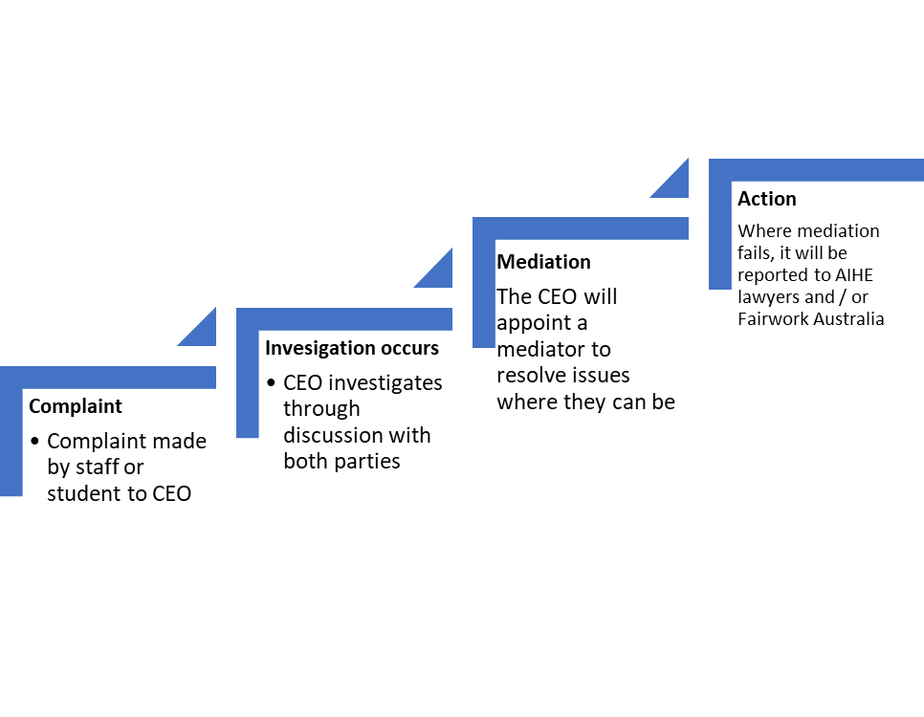

Process (cont)

Process in detail
 | Area | Process
1 | Reporting cases of Harassment, bullying, discrimination internally | - Any student or staff member who believes that she or he has been subjected to unlawful harassment of any kind, or has observed any bullying, harassment or discrimination, has the responsibility to report it immediately to the CEO  - If the is uncomfortable reporting the harassment to the CEO ( for any other reason whatsoever), the student or staff member must report the harassment to the directors of AIHE
2 | Investigation | - Every report of harassment will be investigated promptly and impartially, with every effort to maintain employee confidentiality through mediation or investigation by the CEO or an internal or external mediator or investigator.  - Both parties will be informed of the process and coached through this by the CEO. The accused will also receive a copy of the accusation.
 |  | - Investigation or mediation will occur and actions considered by the CEO
 |  | - The complainant and the accused will be informed of the results of the investigation and the actions to be taken.
3 | Corrective action | - If the CEO finds that its policy has been violated, it will take appropriate corrective and remedial action, up to and including discharge or suspension of the offending student or staff member.  - Where the offence has occurred by a student against a staff member, the student’s fees will not be refunded for the period for which they have attended.
 |  | - Reports and any outcomes of the action will be filed by the CEO and a copy given to the student or staff member
4 | Application to the Commission | - Where an individual is not happy with the results of the investigation, or the harassment continues, they may apply to the Commission for assistance. (See Guide to Anti-Bullying)

Definitions and acronyms
Name/Acronym | Definition and examples
Accused | Person against whom a report of bullying, harassment or discrimination has been made.
Bullying | (as defined by Fairwork)  A worker is bullied if:  - A person or group of people repeatedly act unreasonably towards them or a group  - The behaviour creates a risk to health and safety.  Unreasonable behaviour includes victimizing, humiliating, intimidating, threatening. Whether a behaviour is unreasonable can depend on whether a reasonable person might see the behaviour as unreasonable in the circumstances  Examples of bullying may include:  - Behaving aggressively  - Teasing or practical jokes  - Pressuring someone to behave inappropriately  - Excluding someone from work related events; or  - unreasonable work demands.
Code of Conduct | Refers to the Code of Conduct within AIHE
Complainant | Worker who reports the bullying, harassment or discrimination
Discrimination | (as defined by Fairwork)  When someone is not treated fairly or given the same opportunities because of their race, colour, sexual preference, age, physical or mental disability, marital status, family or carer’s responsibilities, pregnancy, religion, political opinion, national extraction or social origin.  Discrimination occurs when there is an “adverse action” such as firing or demoting someone, because of their characteristics such as race, religion or sex.  Direct discrimination is when someone is treated unfairly, or it is proposed to treat, someone unfairly because of their sex, race, and other grounds, compared to someone else who does not have that characteristic.  Indirect discrimination is when there is a requirement or rule in the workplace that is the same for everyone, but in effect disadvantages people from a particular group more than people form others groups.  In some cases, workplace discrimination is not unlawful where the discrimination occurred because a person is unable to perform the inherent requirements of the position, or when This Fact Sheet is general advice - for further information please see www.fairwork.gov.au or contact Workplace Relations - November 2014 there are genuine occupational requirements for a particular sex, race or age for a person in performing a work role as examples.
Harassment | Harassment may be repeated or unreasonable behaviour directed at an individual or group of people. It may be written or verbal and includes humiliation, abuse, spreading rumours or gossip or any other kind of discrimination prohibited by legislation and is either:  - made by a worker of the Society;  - directed at and offensive to any other worker or any other individual or group that the person knew or reasonably ought to have known would be offensive (e.g., unintended).  Workplace harassment usually consists of a pattern of unwelcome behaviour, however it may consist of just one act where this is of a serious nature, in presenting as a serious risk to safety and/or wellbeing to the people involved. There is no requirement that the harasser intended to offend or harm for an action to be considered harassment. Some forms of harassment are also criminal offences – for example sexual harassment.  Examples of forms harassment include, but are not limited to:  - Verbal and non-verbal conduct  - Sexist/racist jokes  - Suggestive looks, gestures or comments of a sexual nature • Repeated unwelcome invitations  - Sexually explicit emails/ posters/photos/objects  Sexual harassment Sexual harassment means any unwelcome conduct, comment, gesture or contact of a sexual nature, whether on a one-time basis or in a continuous series of incidents that:  - Might reasonably be expected to cause offence, embarrassment or humiliation  - Might reasonably be expected to be perceived as placing a condition of a sexual nature on employment, services, or on any opportunity for training or advancement.  Examples of sexual harassment include, but are not limited to:  - Remarks, jokes, innuendoes or other comments regarding someone’s body, appearance, physical or sexual characteristics or clothing  - Displaying of sexually offensive or derogatory pictures, cartoons or other material  - Persistent unwelcome or uninvited invitations or requests  - Unwelcome questions or sharing of information regarding a person’s sexuality, sexual activity or sexual orientation  - Conduct or comments intended to create, or having the effect of, creating an intimidating, hostile or offensive environment.
Investigator | The investigator is utilised where mediation is not appropriate or fails. An investigator must be a well-trained individual who is able to conduct a formal process with clear documentation. An investigator will not have a reporting line or personal relationship/connection with either the complainant or alleged harasser
Mediator | A mediator is an impartial, neutral party, without decision-making powers, whom both parties accept. The mediator may be the applicable HR representative, or other internal or external party. The goal of mediation is to assist both parties to reach a mutually beneficial agreement.
Reasonable management | Some actions, though they feel uncomfortable and unpleasant for a worker, are not considered bullying behaviour. According to the Fair Work Act 2009, bullying does not include reasonable management action carried out in a reasonable manner. Reasonable management action may include:  - performance management processes  - disciplinary action for misconduct  - informing a worker about unsatisfactory work performance or inappropriate work behaviour  - directing a worker to perform duties in keeping with their job  - maintaining reasonable workplace goals and standards. A manager is entitled to carry out actions and give directions that are consistent with managing the workplace.  However, any reasonable management actions must not only be reasonable but must also be conducted in a reasonable manner. If not, they could still be bullying.
Staff | Refers to a person employed on a permanent or temporary basis to reflect all employees that works in AIHE
Student | Any student who is attending AIHE premises or clinical placements for the purpose of study and learning.
Workplace conduct | That is unlawful- includes discrimination, harassment and bullying, and is addressed in legislation including the Fair Work Act (2009) and Anti-Discrimination Act 1983

References
Name
Australian Commission Human Rights
Fair Work Ombudsmen-Rights and Responsibilities

(Fairwork, 2018)
(Fairwork, 2018)
(Fairwork, 2018)

